BSNL’s Managed Services Offerings
White Papers

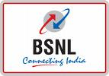
Summery
Bharat Sanchar Nigam Ltd (BSNL), India’s largest ISP telecom company has announced the launch of BSNL Managed Services, providing complete managed solutions to its customers.

BSNL Managed Services will include leased line modems, routers and a host of security services like managed firewalls as well as IP Sec tunnels in-built with the product.

This would give one point of contact to customer to deal with & customer need not handle multi vendors for their different requirements.

Business Model
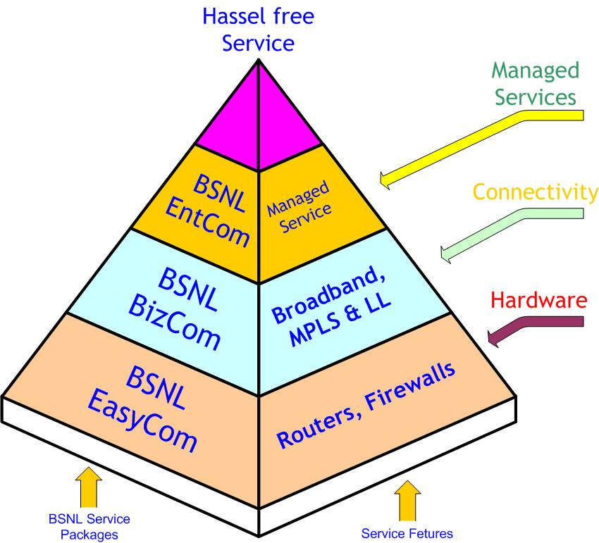

BSNL is offering end to end solution to end customer. BSNL understand the challenge in managing different vendors for different requirement. In a normal scenario end customer has to take care of liaison part, has to interact with OEM who supplies the Networking equipments and the SI who integrate the actual solution. With this new model BSNL has completely eliminated multi desk interaction for customer. With this model customer gets a complete connectivity solution along with the manageability and close monitoring mechanism. Expert hand is always there for customer for his assistance. This model offers Hardware, Connectivity & Management & Monitoring of the solution.

Customer’s Benefits:


BSNL has launched this model to benefit end user with hassle free network connectivity. With this model BSNL will shoulder the Connectivity management responsibility of the end user to facilitate him for concentrating his main business. BSNL would be one point of contact for End user for Connectivity issues, Equipment issues, & New configuration. BSNL will even take care of Equipment replacement activity in case of hardware failure. End customer would get all this with a cost which he has to pay on monthly basis. With this opex model customer will get,
- Connectivity
  - Broad Band
  - Lease Line Circuit
  - MPLS port
- Networking equipments
  - Lease Line Modems
  - Routers with Basic Firewall solution
  - Replacement of Faulty hardware
- Services
  - Configuration (Router & Firewall) Management
  - Link Monitoring
  - Escalations on any malicious activity
  - Escalation on Failure
  - Co-ordination for re-connectivity
  - Helpdesk & Service desk
- SLA
  - 99.00 %
  - Support in specified timeframe.
Customer Support

BSNL understand the importance of “Support” in any solution. BSNL has built a different support Mechanism to support the customer. A 24X7 Man Helpdesk will be available for attending customer’s calls, escalations & to support them around the clock. Customer will get the toll free no on which he can log a request in case if he wants to make any changes in his configuration. Same no can be used to know more about other offerings of BSNL in this arena. Toll free no is manned and equipped with necessary information so customer would defiantly get the solution on his problem.
End Customer can Contact on 1802333334 to know more about offerings

Support lines….

- Customer Can Contact Helpdesk over a Phone 1802 333334

- Customer can fill a Form over a web to know more about the Services.
  - http://www.bsnl.co.in/mls - (link Need to be created)

- Customer can send their queries and escalations on msl@bsnl.co.in. This would be answered immediately with detail solution. in case if any details from customer would be required, Helpdesk will be contacting customer directly

NOC support
Customer will be entitled under this model to get the NOC support. Customer Network will be monitored from BSNL’s NOC with the proactive mechanism. Every Link and hardware utilization will be monitored with threshold set which will enable NOC to take an action before any mishap. It would eventually give the maximum uptime of any network. NOC will support customer even on their requirement. Customer has to log a request and BSNL NOC would reply back immediately. As a practice NOC would perform following activities,

Monitoring Activity

Monitoring Tool: BSNL NOC would be using SNMP tool to keep an eye on all the activities across the customer Network. Every Router, firewall will be monitored with threshold set. This would be a proactive mechanism wherein any mishap will be informed to NOC well in advance and corrective measures will be taken proactively to avoid any outage. Eventually this would provide maximum uptime. This mechanism would monitor following Activities,

- Router Interface Utilization – Inbound traffic in percentage
- Router Interface Utilization – outbound traffic in percentage
- Router Interface Utilization - inbound traffic in bytes
- Router Interface Utilization - outbound traffic in bytes
- Firewall Usages
- Threat Analysis
Monitoring Mechanism would generate different reports for analysis of the bandwidth utilization and Firewall activities.

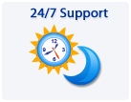
24x7 Support structure
A separate desk would be working on monitoring the network. This would be manned 24X7 and every activity will be monitored around the clock. Experts will be working in three shifts to provide managed services to BSNL’s end customer. Customer can log a call over a mail or through web in case he needs any assistance. Service desk can even be contacted over a phone. In case of any abnormal event, Customer would be contacted and would be informed. After consultation with customer a right action will be taken e.g. if Customer’s B/W utilization would be observed on higher side then call would be made and in case customer is performing some B/W intensive activity then that link would be kept under observation however if there is some unknown activity would be happening a corrective action will be taken or suggestion on it.

Service Request Management

Customer can call to a dedicated support team to log a call or he can log a call over a web which will create a Service Request ticket with unique Service ID. This ticket would be considered as a “Service Request”. This will be handled further in the following way.

- “Service Request Ticket” will be acknowledged by an Expert who will be working on that call.
- Customer will be contacted to understand the details of the problem
- After consultation with customer, identification of problem will be done
- Once the Problem identified, appropriate patch work will be done.
- An expert who will work on Service Ticket will be appending the details of his resolution steps in this ticket. This will be a information for other engineer in case call can not be closed in one shift and has be taken over by an engineer of next shift.
- Customer will be posted on all the steps which will be taken to resolve the issue.
- In case of any “Change”, Remark will be mentioned in the ticket and ticket will be sent to approval authority.
- “Change” will be done as per the approval and ticket will be updated accordingly
- In case Service Desk analysis report demands personal visit of an engineer, it would be made and problem would be handled in person on site.
- In case Client wants some policy change then configuration will be done accordingly from remote.

Replacement Strategy

In case of hardware failure, following process will be followed up,
- Call will be logged in the call logging mechanism
- Required Approval will be taken on the replacement request
- Similar hardware will be arranged from the stock which will be maintained.
- It will be dispatched with the bare minimum configuration
- Engineer will be sent on site to replace failed equipment with the new one
- Box will be configured as per the requirement.
- Once BOX will be configured, Client will be informed & explained on configuration
- Link/Configuration will be tested
- Call report will be signed from Customer
- In consultation with Customer “Service Request” will be closed.
In case of Line fault,
- Call will be logged and sent to BSNL
- Local maintenance officials will be contacted.
- Co-ordination would be done to mitigate the line fault
- Service Ticket will be updated and closed after confirmation from customer.
Offerings
Connectivity Options | Broadband / Internet / MPLS VPN
Bandwidth Options | 64/128/256/512/1024 /2048 Mbps*
Firewall Security | State full Inspection Firewall  User Defined Security Policies  NAT/ PAT  DMZ, etc.
Remote Access VPN | 5 to 50 IPSec VPN Tunnels (as per plan)
Service level Agreement | - 24 x 7 x 365 Monitoring and Helpdesk support  - 99% Uptime guarantee for connectivity and CPE  - 4 Hour response Time (for 8 hours a day, 6 days a week)  - Next Business Day Replacement guarantee  - Security related Respond to priority requests within 30 minutes and non-priority requests within 4 hours  - 24-hour real-time event correlation and interpretation  - Security Event notification within 15 minutes  - Periodic reports (Monthly) to be shared through mail  - Firewall Policy change request within 8 hours (8 x 6 available)  - Event-log storage duration 1 month (longer duration to be charged extra)  - Notification of security update and bug fixes
ISDN Back Up | Free ISDN Backup in select models, uses charges apply.
Reporting | Monthly Report on service Availability and Firewall Activity
Sales Enquiry details
- Local BSNL office

